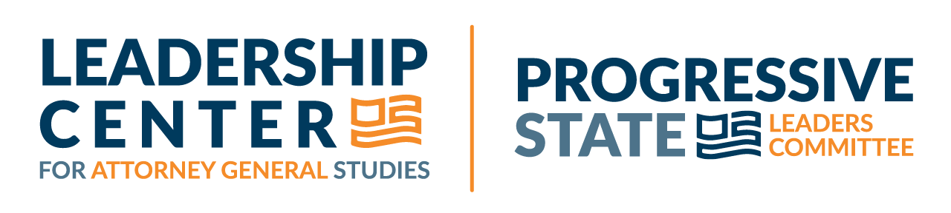
How Progressive State Attorneys General have Protected Citizens’ Right to Vote in the 2024 Election

Across the country, progressive state attorneys general (AGs) have been leading the charge to protect every eligible citizen’s right to cast a ballot and have their votes counted, from the courtroom to the court of public opinion. Along the way, these leaders have scored important victories for voters.
- In Nevada, AG Aaron Ford defeated efforts to remove thousands of eligible voters from the voter rolls, and protected the right of voters to have their absentee ballots counted as long as they arrived in time.
  - Challenges to voter rolls under the National Voter Registration Act (NVRA) have been filed in states across the country, and Nevada is no exception . AG Ford secured a dismissal of the Republican National Committee (RNC) suit against Nevada Secretary of State Francisco Aguilar that alleged that Nevada’s voter list maintenance was inadequate under the NVRA. This dismissal was only the first act in a much longer fight to protect voters from being purged inappropriately from their state voter rolls. The RNC has already filed a new amended complaint.
  - The RNC also filed suit to prevent Nevada from counting absentee ballots that arrived within three days of the election via mail but without a postmark, in the same manner that state law requires ballots with an indeterminate postmark to be counted. The state Supreme Court’s ruling ensures that ballots would not be unnecessarily rejected through no fault of the voter.
- In Michigan and North Carolina, AG Dana Nessel and AG Josh Stein ensured that every eligible voter who lives abroad as well as members of the armed forces and their families were able to participate in this year’s election, despite efforts to block their ballot access. In both states the RNC challenged the voting eligibility of voting-age children and spouses of military and overseas residents because those individuals had not resided in the state. The Federal Uniformed and Overseas Citizens Absentee Voting Act allows citizens who are not currently residents of the state to vote.
  - The Michigan court ruled on the merits that both state and federal law, as well as the Michigan constitution, allow the eligible spouses and dependents of Michigan overseas and military voters also to cast their ballots.
  - In North Carolina, the court refused to grant the RNC a temporary restraining order, ruling that plaintiffs failed to demonstrate that provisions allowing foreign-born U.S. citizens to vote had ever been used fraudulently by anyone who was ineligible to vote.
- In New York, AG Letitia James successfully defended the state’s new absentee voter laws, all the way to the state’s highest court. This result protects the right of every voter in New York to have access to vote by mail without requiring an excuse, making voting more accessible to all of New York’s citizens.
- The National Association of Attorneys General released a statement leading up to the November 5, 2024, election on behalf of a bipartisan coalition of 51 Attorneys General condemning violence in response to the election results and calling for all Americans to respect the integrity of the voting process.
While the 2024 election process is winding down, the work of protecting democracy remains a top priority for progressive attorneys general across the country. Indeed, the task of defending the right of all eligible citizens to cast a ballot, and of all candidates to campaign freely, has never been so important for our country. State attorneys general are prepared to continue to defend our rights.

See RNC v. Aguilar, Case No. 2:24-cv-00518-CDS-MDC, U.S. District Court District of Nevada (October 18, 2024) (https://www.democracydocket.com/wp-content/uploads/2024/03/121-2024-10-18-Order-granting-defendants-motion-to-dismiss.pdf).
See RNC v. Aguilar, Second Amended Complaint, No. 2:24-cv-00518-CDS-MDC (Nov. 11, 2024) (https://www.democracydocket.com/wp-content/uploads/2024/03/124-2024-11-11-Second-amended-complaint-WM.pdf).
See RNC v. Aguilar, Nevada Supreme Courter Order 24-40423 (Oct. 28, 2024) (https://www.democracydocket.com/wp-content/uploads/2024/06/2024-10-28-Order-WM.pdf).
See Michigan Republican Party et al. v Benson, Case No. 24-000165-MZ, Michigan Court of Claims (Oct. 10, 2024) (https://www.democracydocket.com/wp-content/uploads/2024/10/2024-10-21-Order-and-opinion-granting-defendants-motion-for-summary-judgment.pdf).
See Kivett v. NC State Board of Elections, Superior Court Order, File no. 24CV031557-910 (Oct. 21, 2024) (https://www.democracydocket.com/wp-content/uploads/2024/10/2024-10-21-Order-denying-Republican-plaintiffs-motion-for-preliminary-injunction.pdf). While the plaintiffs filed a supersedeas in the NC Supreme Court, no action was taken prior to the election, allowing these voters to cast ballots lawfully. See Kivett v. NC State Board of Elections, Plaintiffs’ Petition for Writ of Supersedeas and for Discretionary Review, Supreme Court of North Carolina No. P24-735 (Nov. 1, 2024) (https://www.democracydocket.com/wp-content/uploads/2024/10/2024-11-01-petition.pdf).
See Amedure v. State of New York, State of New York Court of Appeals, Opinion, No. 126 (Oct. 31, 2024) (https://www.democracydocket.com/wp-content/uploads/2023/09/2024-10-31-Opinion.pdf).
National Association of Attorneys General, “Attorneys General Issue Bipartisan Statement Condemning Possible Violence in Response to Election Results,” Nov. 4, 2024 (https://www.doj.state.or.us/wp-content/uploads/2024/11/STATEMENT-Possible-Violence-in-Response-to-Election-Results.pdf).

