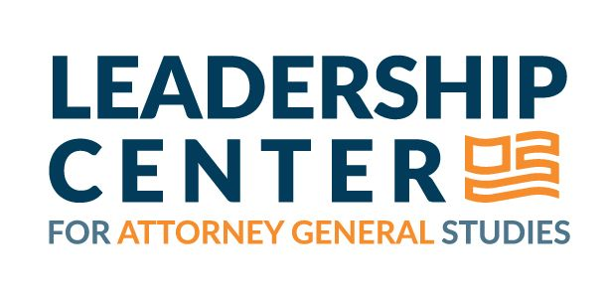
Protecting Our Water: The Vital Role Of State Attorneys General In Enforcing
The Clean Water Act And The Safe Drinking Water Act

Authors: AG Studies Staff and Policy Fellows

Introduction

When our water is compromised, the consequences can be dire—harming public health and disproportionately impacting communities of color, low-income populations, and Indigenous people. For instance, the Flint water crisis exposed over 100,000 residents to lead-contaminated drinking water, highlighting the critical need for effective enforcement of water protection laws. The Clean Water Act (CWA) and the Safe Drinking Water Act (SDWA) are cornerstone federal laws designed to safeguard our nation’s surface waters and drinking water supply. As chief legal officers, state attorneys general (AGs) play a pivotal role in enforcing and defending these acts, significantly influencing the health and safety of their communities.

Importance of the Clean Water Act and the Safe Drinking Water Act

In response to widespread water pollution, Congress amended the Federal Water Pollution Control Act in 1972, establishing guidelines for regulating pollutant discharges into surface waters and thereby creating the CWA. This act aims to restore and maintain the integrity of our oceans, rivers, lakes, and wetlands by imposing strict limits on the types and quantities of pollutants that can be discharged into U.S. waters.

The SDWA, enacted in 1974, sets foundational safety and quality standards for public drinking water. While the CWA focuses on ensuring that our nation’s waters are fishable and swimmable, the SDWA prioritizes safeguarding public health and ensuring the quality of drinking water. Together, these acts form a federal framework dedicated to ensuring that communities have access to clean and safe water.

The Authority of State Attorneys General

The Environmental Protection Agency (EPA) is the federal agency responsible for implementing and enforcing water standards under the CWA and the SDWA. However, both acts empower states to assume primary responsibility, enabling them to create standards that meet or exceed federal guidelines. State AGs are crucial in this process, holding violators accountable by launching investigations and prosecutions. They may also provide legal counsel to state agencies, assist in developing regulations and legislative proposals, and advocate for stronger protections during rulemaking. Additionally, AGs can initiate lawsuits against the federal government and file amicus briefs to influence significant judicial cases.

Protective Actions Taken by Progressive State Attorneys General

Below are examples of key protective actions taken by progressive state AGs to safeguard water quality and public health under the CWA and the SDWA:

- Advocating for Stronger Wastewater Standards: In 2024, a coalition of six AGs, led by California AG Rob Bonta, filed comments urging the EPA to adopt the most protective standards for regulating wastewater pollutants from meat and poultry facilities, noting the disproportionate impact of polluted waters on communities of color. This action demonstrates how state AGs can leverage their positions to promote clean water access for all residents.

- Supporting Safer Drinking Water Standards: In 2023, a coalition of seventeen AGs, led by Wisconsin AG Josh Kaul, filed comments supporting the EPA’s decision to establish enforceable drinking water standards for six harmful per- and polyfluoroalkyl substances, also known as PFAS or “forever chemicals.” PFAS have been linked to a wide range of detrimental health effects, such as an increased risk of certain cancers, developmental delays, and immune system disruptions. The coalition also urged the EPA to consider setting standards for other PFAS, underscoring the critical role of state AGs in advocating for safer public drinking water.

- Enforcing SDWA Requirements: In 2023, former New Jersey AG Gurbir S. Grewal announced the guilty plea of an individual who previously worked for the South River Water Department for submitting false water samples. This case exemplifies how state AGs can hold violators of the SDWA accountable through criminal investigations and prosecutions.

- Defending CWA Protections: In 2022, California AG Rob Bonta filed a multistate amicus brief with the U.S. Supreme Court, arguing that a narrow interpretation of wetlands would undercut the CWA’s protections and negatively affect downstream states. This case underscores the critical role of state AGs in safeguarding essential water protections.

- Challenging Unlawful SDWA Regulations: In 2021, a coalition of ten AGs, led by New York AG Letitia James, challenged regressive revisions to the Lead and Copper Rule, which regulates the levels of lead and copper in drinking water. They argued that the revisions would weaken crucial protections against lead in drinking water, endangering public health. This lawsuit illustrates how state AGs can work together to proactively hold federal agencies accountable for weakening the SDWA.

Consequences of Failing to Uphold the CWA and the SDWA

When state AGs fail to effectively enforce the CWA and the SDWA, the consequences can be severe. The Flint water crisis resulted in devastating health outcomes, drawing sharp criticism of former Michigan AG Bill Schuette for his office’s delayed responses to urgent water quality complaints. In addition, legal actions taken during the Trump Administration by former Oklahoma AG Scott Pruitt were influential in the significant rollbacks of the CWA, drastically reducing the number of U.S. waterways eligible for federal protection. This alarming shift raised grave concerns about the long-term implications for water quality and public health. These examples demonstrate how imperative it is for state AGs to actively commit to robustly defending and enforcing our nation’s water laws.

Conclusion

While the CWA and the SDWA are fundamental to protecting our nation’s water quality, progressive state AGs are crucial defenders and enforcers of these laws. Through their leadership and actions, these AGs work to safeguard public health and promote equitable access to clean and safe water for all communities. As champions of a sustainable future, they are indispensable in the ongoing fight for water safety and environmental justice.

